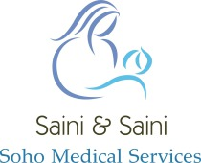
Website Survey Results
52 Completed returns in August 2019
“How can we improve our website to help you more?”
You said ………
You need a search bar
Needs to be more eye catching
More signposting
Links to trusted websites.

We did ………
- A Search bar will be added
- Link to benefits / sick pay / SC1 form and other trusted health websites
- Add a short paragraph explaining Patient access
- Add a standard registration form
- Information about disabled access
- NHS choices link
- Regular blog
- Improve design – add dynamic images
- Improve patient knowledge of its existence
- Improved visibility through social media – Facebook (booster advertising etc.)

